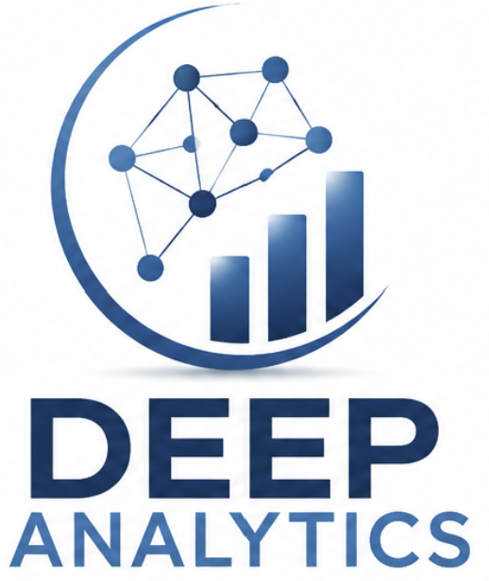

Deep Analytics Intelligence Work Bench
Investor Information
Investment opportunity, competitive position and future product development
Deep Analytics welcomes expressions of interest from investors in the Deep Analytics Intelligence Work Bench and its existing and future products.
The opportunity is an emerging, AI-assisted investigative platform designed to bring graph analysis, case management, timelines, document intelligence, communications analysis and specialist analytical modules into one practical environment.
Version 1.0 | September 2026

Investment Opportunity
Deep Analytics is developing the Intelligence Work Bench as an integrated analytical environment for organisations that need to identify and understand complex relationships across diverse data. The product is designed around the investigation, with the case as the organising principle and graph intelligence connecting entities, events, evidence and analytical outputs.
The commercial opportunity is the space between a specialist link-analysis tool and a very large enterprise data platform. Work Bench is intended for organisations and teams that need advanced investigative capability, rapid deployment and an investigator-friendly workflow without beginning with an enterprise-scale implementation.

Current product proposition
- Configurable graph-database creation and graph and SQL-backed network analysis.
- Integrated case, person, organisation, crime, evidence and linkage records, supported by a case timeline.
- Document search, call-data-record and tower analysis, geospatial intelligence, DNA and genealogy analysis, and relationship-first navigation.
- AI-assisted summaries, hypotheses and recommended investigative steps, with the analyst retaining judgement and accountability.
- A modular architecture intended to support additional data sources and analytical services over time.

Why the opportunity is differentiated
Work Bench combines capabilities that commonly require several products, integrations and specialist workflows. Its potential advantage is not one isolated feature; it is the way graph analysis, operational case work and specialist analytical modules are designed to work together.
Deep Analytics can also tailor a focused product more quickly than large platform vendors. That agility may support pilot-led adoption, specialist deployments and progressive product development. Commercial pricing, customer demand, production scale and market fit remain matters for validation.

Development stage and investment focus
The current R1 application is demonstrable. The next phase is to mature the product through customer validation, security review, production engineering and selected new capabilities. Investment would support the transition from a capable investigative application to a commercially deployable intelligence platform.

Competitor Analysis
The relevant comparison is not a claim that Deep Analytics has displaced established products. i2 Analyst's Notebook is a mature specialist visual-analysis environment, while Palantir is a much broader enterprise ecosystem. Deep Analytics is pursuing a distinct position centred on an integrated, AI-assisted investigative workspace.
Area | i2 Analyst's Notebook | Palantir platforms | Deep Analytics Work Bench
Primary focus | Mature specialist visual link and temporal analysis | Enterprise data, operations, security and governed AI | Investigator-centred graph analysis and integrated workflow
Established strength | Chart construction, editing, layouts and analyst adoption | Enterprise integration, scale, collaboration, governance and deployment | Graph, cases, timelines, documents, CDR, mapping, DNA and AI in one workspace
Current relative position | More mature visual-analysis product | Far broader enterprise platform | Emerging, demonstrable specialist platform
Deployment fit | Single-user and enterprise options | Large enterprise and government programs | Workstation and focused team deployments; broader scale remains to be proven
AI and workflow | Available through newer capabilities and the wider ecosystem | Strong governed AI and workflow automation | AI summaries, hypotheses and next-step recommendations designed into the investigative workflow
Product opportunity | Deep charting and established tradecraft | Comprehensive enterprise operating environment | The gap between specialist link analysis and a very large enterprise implementation

i2 Analyst's Notebook
i2 remains ahead in mature interactive chart construction, visual link-analysis tradecraft, chart presentation, very large chart handling, specialist integrations, training, support and deployment history. Deep Analytics should be positioned as integrating a broader investigative workflow around the graph, rather than claiming to match three decades of charting refinement.

Palantir
Palantir is substantially ahead in enterprise-scale integration, distributed compute, collaboration, granular security, workflow automation, governed AI, application tooling, deployment management, APIs, monitoring, lineage and global reference deployments. Deep Analytics should not be presented as a replacement for Palantir's entire platform.

Deep Analytics position
The credible position is an emerging analyst-centred platform that integrates graph analysis, cases, documents, communications, timelines, specialised analysis and AI. It is particularly relevant to focused teams and small to medium organisations seeking a practical desktop or hybrid pathway.

Future Product Development
Future development is intended to deepen the common services that connect the current Work Bench modules, then extend collaboration, integrations and investigator assistance. The priorities below are proposed directions and should not be represented as completed functionality.

Core analytical services
- Complete central entity and relationship services.
- Add a central evidence service.
- Strengthen entity resolution, provenance and reusable relationship services.

Document and intelligence workflows
- Complete pattern matching and document intelligence.
- Convert extracted entities and relationships into case and graph workflows.
- Extend evidence-based AI summaries, hypotheses and recommended next steps.

External data and specialist integration
- Develop connectors for approved external databases and operational systems.
- Evaluate facial recognition, vehicle registration, financial intelligence, social media, CCTV, GIS and biometric integrations.
- Expand communication, geospatial and specialist analytical modules.

Operational maturity
- Add collaboration, audit trails, permissions and multi-user workflow features.
- Strengthen security review, production engineering, deployment and support.
- Validate performance, scale and usability with controlled customer pilots.

Future product pathways
- Develop the extensively designed R2 Mobile Field App when commercial priorities support it.
- Explore focused products that reuse the Work Bench entity, relationship, evidence and AI services.
- Maintain a modular architecture so new capabilities can be added without redesigning the whole platform.

Product development principle
New development should be tested against one practical question: does it make the analyst's or investigator's work easier, more reliable or more accountable? This principle keeps the roadmap focused on operational value rather than disconnected features.

Investment Enquiry
Deep Analytics welcomes expressions of interest from investors in the Intelligence Work Bench and its existing and future products.
Initial discussions may cover the product vision, current R1 demonstration, proposed development roadmap, target markets, pilot opportunities and the investment required to support commercialisation. Detailed commercial, technical and financial information can be provided through an appropriate due-diligence process.

Contact Deep Analytics
Email: info@deepanalytics.com.au
Company: Deep Analytics Pty Limited
ACN: 698 199 370
Website: deepanalytics.com.au

Important information
This document is provided for preliminary discussion only. It is not an offer, invitation, recommendation or financial product disclosure document. Product plans are subject to technical, commercial, regulatory and customer validation. Prospective investors should undertake their own due diligence and obtain independent legal, financial and tax advice.

Summary
Deep Analytics is building an AI-assisted investigative intelligence platform with a demonstrable R1 foundation and a defined path toward broader services, integrations and operational maturity. Its proposed market position is a practical, investigation-centred environment between specialist link-analysis products and large enterprise platforms.

